Cross Bearer
Entrance Procession
- Move slowly and respectfully, stop at the foot of the Altar, turn right and go to cross stand.
- Put the cross in its stand, and go to your seat. Remain standing.

Introductory Rites
Collect Prayer (after Gloria, except in Advent & Lent when there is no Gloria)-
- The priest will say, “Let us pray,” or, “Oremos,” if in Spanish. Take the Roman Missal from table, and hold it slightly to the side of the priest.
- Close the Roman Missal and put it back on the table when he is finished.
- Return to your seat and sit down for the Liturgy of the Word.

Liturgy of the Word

Listen to the readings and the priest’s or deacon’s homily respectfully.

Stand when it is time to recite the Creed and during the Universal Prayers (Prayers of the Faithful/Intercessions). Don’t sit down after the prayers are finished even though all the people do.

Liturgy of the Eucharist
Preparation of Gifts (begins when Father asks the Children to bring up food gifts)-
- Take Roman Missal from table to Altar (either place on the altar or in the book stand if it is present), and return to your seat. Wait for candle bearer one to go with you carrying the chalice and paten. Go as a team. Don’t race or rush.
- Remember to genuflect to tabernacle when returning. Wait for candle bearer one and come back as a team. Don’t race or rush.
- Be attentive and respectful during the Eucharistic Prayer.
Communion
- When the Priest or Deacon says, “Let us offer each other the sign of peace,” step up to the side of the altar and exchange sign of peace with the priest and other servers.
- After the sign of peace, form semicircle around Altar with Extraordinary Ministers of Holy Communion in preparation to receive Holy Communion.
After Communion- Take Roman Missal from Altar and return it to credence table.
- When the priest is finished distributing Communion, watch to see if he needs the water to purify his chalice. He will look to you if he does.
Prayer after Communion –
- The priest will say, “Let us pray,” or “Oremos.” Take Roman Missal from credence table, Take the Roman Missal from table, and hold it slightly to the side of the priest. When he is finished, close and put back on the table, return to seat (NOTE: Same as Collect Prayer in step 3)

Concluding Rites
Recessional –
- When the people begin to sing, go to the cross stand, take the cross, move slowly and respectfully to the foot of the Altar and stop in center aisle about six pews back to form the head of the procession. NOTE: leave room for the candle bearers, bell ringer, and the reader in front of you. Turn around when the priest genuflects, and slowly and respectfully walk down the aisle.
- Return processional cross to the altar server room.
- Remove and hang up your alb.

Candle Bearer I
Entrance Procession
- Move slowly and respectfully following the Cross Bearer, stop at the foot of the Altar, turn left and go to candle stand.
- Put candle in stand, and go to your seat. Remember to genuflect to tabernacle while crossing between it and the Altar together with candle bearer two.

Introductory Rites

Liturgy of the Word

Listen to the readings and the priest’s or deacon’s homily respectfully.

Stand when it is time to recite the Creed and during the Universal Prayers (Prayers of the Faithful/Intercessions). Don’t sit down after the prayers are finished.

Liturgy of the Eucharist
Preparation of the Gifts (begins when Father asks the Children to bring up food gifts)-
- Take priest’s chalice/paten from credence table to Altar, return to seat. Remember to genuflect to tabernacle while returning. Wait for the cross bearer who will take the Roman Missal to the altar with you. Go to the altar and come back as a team. Don’t race or rush.
- When the priest goes down to receive the gifts, go with him and stand to the side of the priest.
- Take the bread/wine (whichever he gives you) to the Altar. Place it on the altar.
- Genuflect to the tabernacle and go to the credence table.
- Take cruet with water and dish and stand at the side of the altar holding them. (NOTE: do not set them down on the Altar.)
- Hand the priest (or the deacon if he is present) the water, and take it when he hands it back.
- Wash the priest’s hands. (Candle bearer two will have the towel to dry his hands.)
- Return water and dish to credence table together with candle bearer two who has the towel.
- Be attentive and respectful during the Eucharistic Prayer.
Communion-
- When the Priest or Deacon says, “Let us offer each other the sign of peace,” step up to the side of the altar and exchange sign of peace with the priest and other servers.
- After the sign of peace, form semicircle around Altar with Extraordinary Ministers of Holy Communion in preparation to receive Holy Communion.

Concluding Rites
Recessional-
- When the people begin to sing, go to candle stand with candle bearer two, take candle, move slowly and respectfully to the foot of the Altar move slowly and respectfully to the foot of the Altar and stop in center aisle about four pews back to form the procession. (NOTE: make sure that the cross bearer is behind you.).
- Turn around when the priest genuflects, slowly and respectfully follow the cross bearer down the aisle side-by-side candle bearer two. Leave about two pews between you and the cross bearer.
- Return candle to the altar server room.
- Remove and hang up your alb.

Candle Bearer II

Entrance Procession
- Move slowly and respectfully following the Cross Bearer, stop at the foot of the Altar, turn left and go to candle stand.
- Put candle in stand, and go to your seat. Remember to genuflect to tabernacle while crossing between it and the Altar together with candle bearer one.

Introductory Rites

Liturgy of the Word

Liturgy of the Eucharist
Preparation of the Gifts (begins when Father asks the Children to bring up food gifts)-
- You can be seated after the prayers even though other servers will be standing to do different tasks. The Cross bearer and Candle Bearer One will stand and move to do their duties.
- When the priest goes down to receive the gifts, go with him and stand to the side of the priest.
- Take the bread/wine (whichever he gives you) to the Altar. Place it on the altar.
- Genuflect to the tabernacle and go to the credence table.
- Take towel to the side of the altar along with candle bearer one who has the dish and cruet of water. (NOTE: do not set them down on the altar.) Offer the priest the towel after he washes his hands; return the towel to credence table together with candle bearer one.
- Be attentive and respectful during the Eucharistic Prayer.
Communion-
- When the Priest or Deacon says, “Let us offer each other the sign of peace,” step up to the side of the altar and exchange sign of peace with the priest and other servers.
- After the sign of peace, form semicircle around Altar with Extraordinary Ministers of Holy Communion in preparation to receive Holy Communion.

Concluding Rites
Recessional-
- When the people begin to sing, go to candle stand with candle bearer one. Remember to genuflect to the tabernacle when you pass by it. Take a candle and then move slowly and respectfully to the foot of the Altar and stop in center aisle about four pews back to form the procession. (NOTE: make sure that the cross bearer is behind you.)
- Turn around when the priest genuflects, slowly and respectfully follow the cross bearer down the aisle side-by-side candle bearer one. Leave about two pews between you and the cross bearer.
- Return candle to the altar server room.
- Remove and hang up your alb.

Bells
Entrance Procession
- Move slowly and respectfully following the Cross Bearer and candle bearers in the center of the aisle. Stop at the foot of the Altar, turn right and go to your seat next to the cross bearer.
- Remain standing.

Introductory Rites

Liturgy of the Word

Listen to the readings and the priest’s or deacon’s homily respectfully.

Stand when it is time to recite the Creed and during the Universal Prayers (Prayers of the Faithful/Intercessions). You can be seated after the prayers even though other servers will be standing to do different tasks.

Liturgy of the Eucharist
Preparation of Gifts (begins when Father asks the Children to bring up food gifts)-
- Be attentive and respectful during the Eucharistic Prayer.
- After the Holy, Holy, Holy is sung, kneel. Watch for the priest to extend his hands over the gifts of bread and wine and ring the bells briefly once. It will look like this:
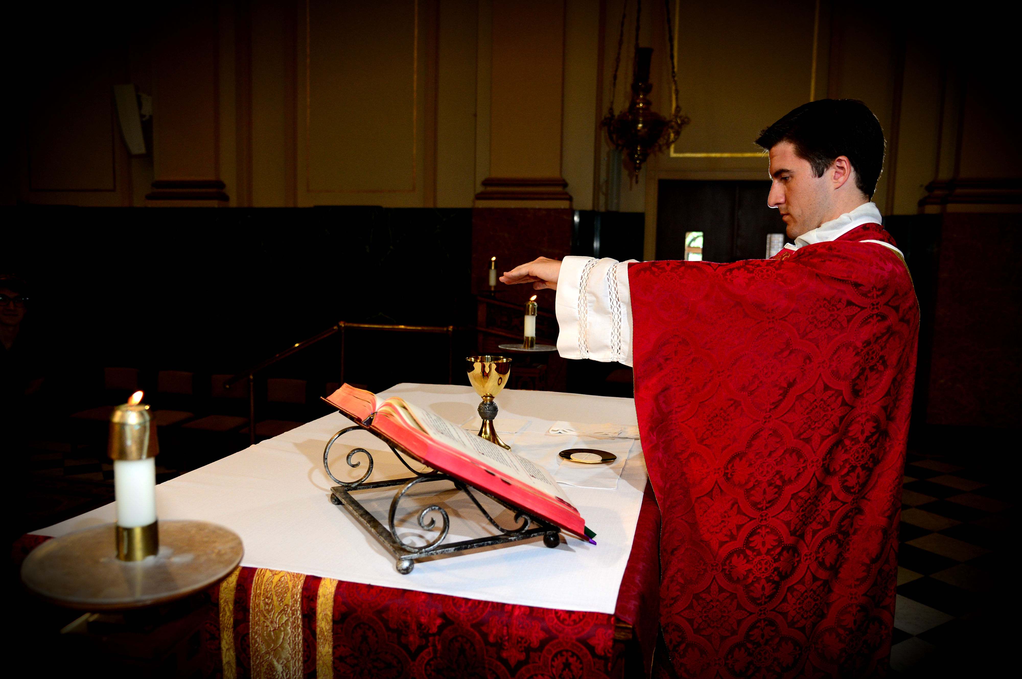
Epiclesis – the time when the priest extends his hands over the bread and wine and asks the Holy Spirit to change them into the Body and Blood of Christ.

- After the priest says, “This is my body which will be given up for you,” and lifts up the Body of Christ, ring the bells three short times. It will look like this when it is time to ring:

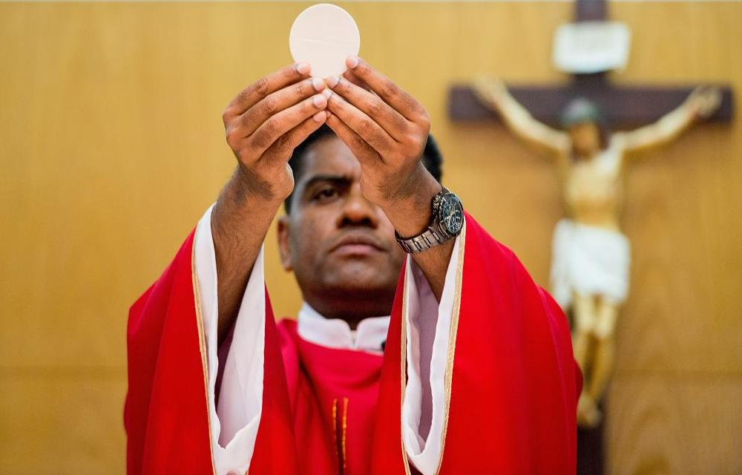
Showing of the Body of Christ to the Assembly.

- After the priest while holding the chalice says, “Do this in memory of me,” and lifts up the chalice holding the Blood of Christ, ring the bells three short times. It will look like this when it is time to ring:
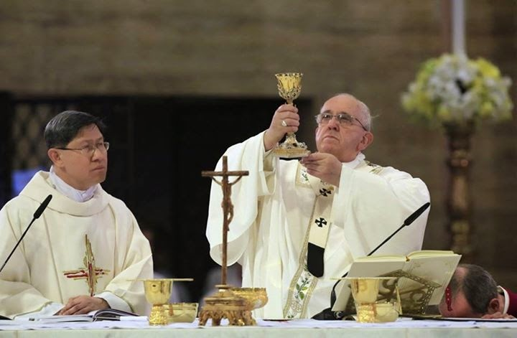
Showing of the Chalice holding the Blood of Christ to the Assembly.

Communion
- When the Priest or Deacon says, “Let us offer each other the sign of peace,” step up to the side of the altar and exchange sign of peace with the priest and other servers.
- After the sign of peace, form semicircle around Altar with Extraordinary Ministers of Holy Communion in preparation to receive Holy Communion.

Concluding Rites
Recessional –
- When the people begin to sing, follow the cross bearer and move slowly and respectfully to the foot of the Altar and stop in center aisle about two pews back to form the procession. NOTE: the candle bearers process out ahead of you and the reader processes behind you. Turn around when the priest genuflects, and slowly and respectfully walk down the aisle.
- Remove and hang up your alb.

