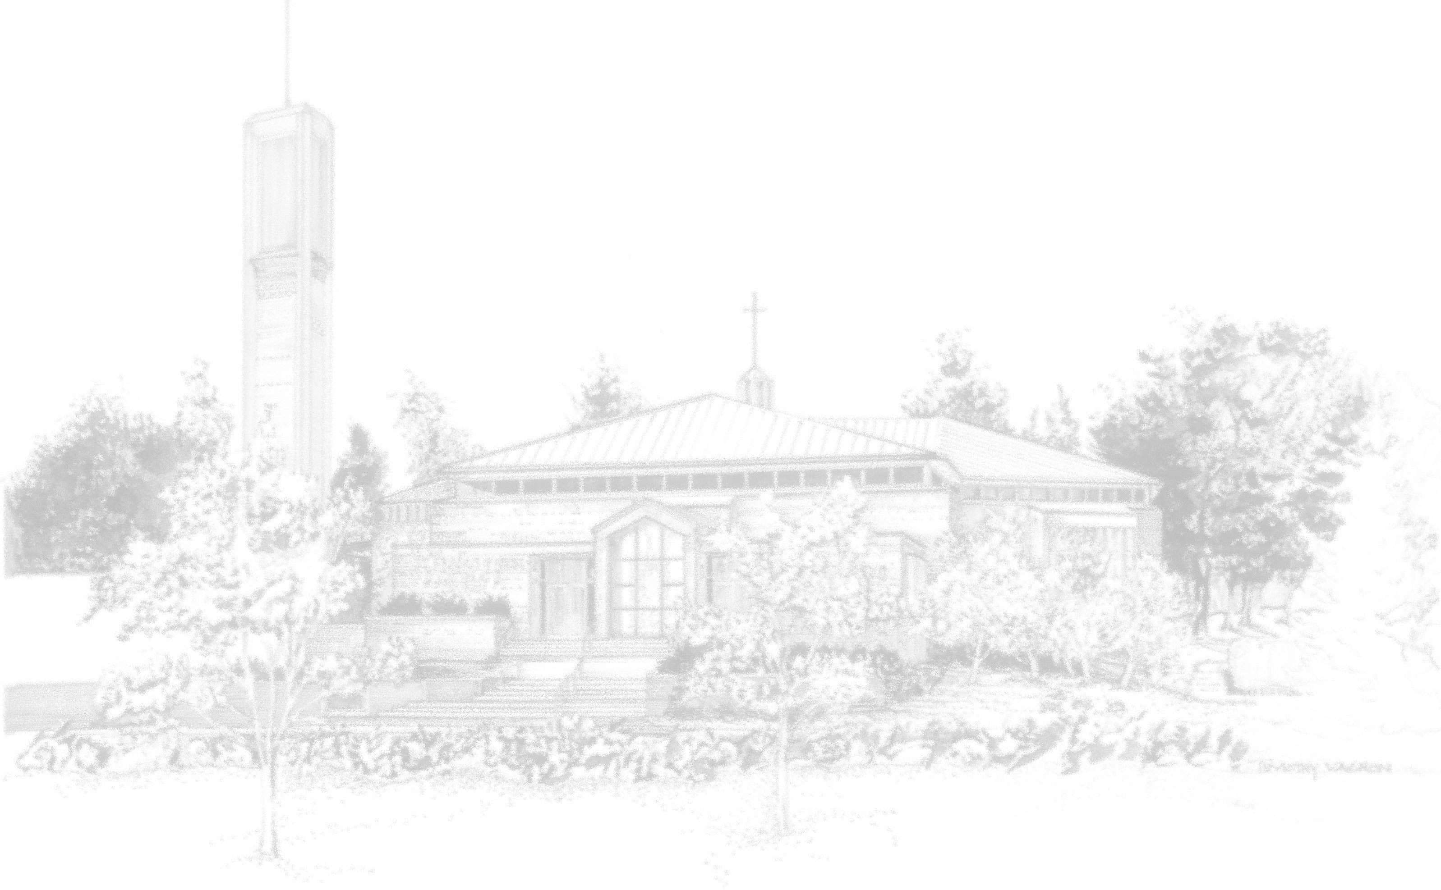
:ALTAR SERVER’S REGISTRATION
2017-2018

NAME:_________________________DATE OF BIRTH______________

ADDRESS:___________________________________________________

CITY:_______________________________________ZIP:_____________

PARENT/GUARDIAN NAME:___________________________________

PARENT/GUARDIAN PHONE:__________________________________

PARENT/GUARDIAN EMAIL:___________________________________

SCHOOL:_____________________________________GRADE________

MASS PREFERENCE:

____ 5:00 p.m. Saturday
____ 7:00 p.m. Saturday (This Mass is in Spanish. / Esta Misa es en Español)
____ 8:30 a.m. Sunday
____ 10:30 a.m. Sunday
____ 12:30 p.m. Sunday
____ 5:00 p.m. Sunday

SPECIAL NOTES AND NAMES OF FAMILY MEMBERS WHO ALSO VOLUNTEER FOR MASS:

